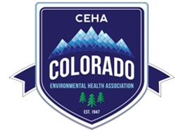
Colorado Environmental Health Association
12110 Pecos St., Ste. 220 | Westminster, CO 80234 | 303-433-4446

To: [Name], [Company Name]
Thank you for supporting the Colorado Environmental Health Association’s 62nd Annual Education Conference Silent Auction.
On [date], you donated the following auction item(s):
- [Two22 Brew Gift Basket including a growlers, two stickers, and a $10 gift card.]
valued at: [$30]
This donation will help our organization raise needed monies for our scholarship fund.
Your donation and support of this local organization is greatly appreciated.
For more information on the Colorado Environmental Health Association (CEHA) visit us at www.cehaweb.com.
CEHA’s Tax Exempt Number is 23-702939.
Please maintain this receipt for your records.

CEHA confirms it did not provide you any goods or services in exchange for this donation. For
purchased items it is your responsibility to submit value received for tax reporting. Any moneys paid for Registration are not tax deductable. Please consult a tax advisor.

